Recipe Warehouse Be a Chef

School of Business

University of Houston – Clear Lake

**Submitted by:**

Komal Rahane

**Contents**

Chapter 1 - Introduction ............................................................................................................. 4

1.1 Motivation ............................................................................................................................ 4

1.2 Project Overview....................................................................................................................5

Chapter 3 – Technologies .......................................................................................................... 6

Chapter 4 - System Design.......................................................................................................... 7

4.1 Use-Case Diagram................................................................................................................. 7

4.2 Class Diagram....................................................................................................................... 7

Chapter 5 – Screenshot of Appliaction...................................................................................... 8

5.1 Screenshots ………………………………………………………………………………………………………………..……8

5.2 Details of web Service ……………………………………………………………………………………………….……12

Chapter 6 – Conclusion………………………………………………………………………………………………………… 13

**Abstract**

In this project I have built a web application “Recipe Search Engine Using Yummly API”. This application is central information hub for the kitchen—connecting consumers with recipe ideas, ingredient lists, and cooking instructions. It will serve best for the people who uses digital tools to plan their cooking, these days almost everyone does.

The various features available for users in this application are as following. Users can search for their favorite dishes. The search results contain information about ingredients list, total time needed for cooking, user’s rating and cooking directions. Basic search filters are provided to filter out the search results like Breakfast, Lunch and Dinner recipes. The order of displayed results can be sorted according to ratings, total time required to prepare the dish. User can create an account and build their own favorite recipe collection by liking the recipes displayed. The liked recipes are stored into user’s account and user can view, add and delete those recipes anytime from his recipe collection. Users can use their social networking platform Facebook account credentials to log into this application or create a new account in this application.

The application will communicate with the Yummly API to consume data from it. The Yummly API is largest recipe information aggregator with over one million recipes data.

**Chapter 1 - Introduction**

**1.1 Motivation**

The motivation to develop this “Recipe search engine using Yummly API” Web Application comes from my urge to learn technologies like ASP.NET with MVC, jQuery, AJAX and RESTful web services. A Web service is a service offered by an electronic device to another electronic device, communicating with each other via the [World Wide Web](https://en.wikipedia.org/wiki/World_wide_web). [REST](https://en.wikipedia.org/wiki/Representational_state_transfer)-compliant (Representation of State Transfer) Web services is one of the two identified major classes of Web services, in which the primary purpose of the service is to manipulate representations of [Web resources](https://en.wikipedia.org/wiki/Web_resource) using a uniform set of [stateless](https://en.wikipedia.org/wiki/Stateless_protocol) operations. Also my interest to learn the implementation of OAuth to log users into this application. OAuth is an [open standard](https://en.wikipedia.org/wiki/Open_standard) for [authorization](https://en.wikipedia.org/wiki/Authorization), commonly used as a way for Internet users to log into third party websites using their Microsoft, Google, Facebook etc. accounts without exposing their password.

**1.2 Project Overview**

This web application is central information hub for the kitchen—connecting consumers with recipe ideas, ingredient lists, and cooking instructions. Nowadays people rely on web for any kind of information. So by building a web application we can serve many users who are looking for recipe ideas and instructions, list of ingredients for that recipe on the web.

The different functionalities available for the users in this application are as following. Users can search for their favorite dishes. The search results contain information about ingredients required, total time needed for cooking, user’s rating and cooking directions. Basic search filters are provided to filter out the search results like Breakfast, Lunch and Dinner recipes. The order of displayed results can be sorted according to ratings, total time required to prepare the dish. User can create an account and build their own favorite recipe collection by liking the recipes displayed. The liked recipes are stored into user’s account and user can view, add and delete those recipes anytime from his recipe collection. Users can use their social networking platform Facebook account credentials to log into this application or create a new account in this application.

The application will communicate with the Yummly API to consume the data from it. The Yummly API is largest recipe information aggregator with over one million recipes data in it.

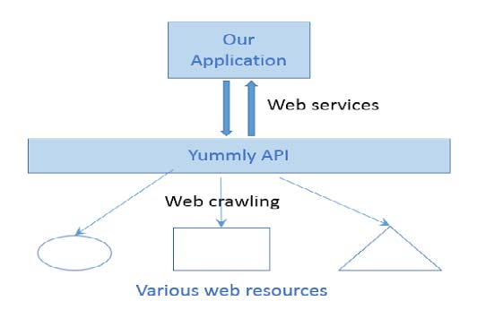

**Figure 1.1 Diagram explaining interaction between our Application and Yummly API**

The above diagram best explains the relation between the Yummly API and the project. Yummly crawls the web and gets recipes information from various sources on web and store recipes data in their servers. They provide web services for other authenticated applications to communicate with them and pull data from their servers. Our application will first authenticate with that API and then pull the required data from it into our application. These web API calls are completely RESTful in nature.

**Chapter 3 – Technologies**

This chapter includes the details of the latest technologies and tools used to build this application. Following are the technologies used in the development of the application.

● **ASP .NET:** It is a framework for building standard and scalable web applications.

● **C#:** It is an object oriented programming language which was developed by Microsoft. It is a general purpose language which has proven to be very efficient to develop web applications.

● **jQuery :** jQuery is a library of JavaScript which is a programming language for the web, used to create dynamic web pages. In this project most of the views are written in jQuery. These scripts are responsible for features such as user input validation (e.g., checking length of password)

● **LINQ:** LINQ stands for Language-Integrated Query. Unlike traditional queries, where query output is expressed as simple strings without any type checking at compile time, 59 LINQ queries are written against strongly typed objects which hold the output of the query without any data loss (these objects match the table structure). It is also easier to use these objects in our code.

● **Visual Studio 2015:** Visual studio is an Integrated Development Environment (IDE) developed by Microsoft and it helps to build various ASP.NET web applications. It also helps in building console as well as GUI applications that can be in native code combined with managed code for all platforms that can be supported by Windows, .NET framework etc. There are several other built-in tools which include a forms designer which can also be used to build GUI applications, web/ class/ database schema designers etc.

**Chapter 4 - System Design**

Requirements gathering followed by careful analysis leads to a systematic Design i.e. Object Oriented Design (OOD).

**4.1 Use-Case Diagram**

A use case diagram depicts the application from an external observer perspective. Use case diagram identifies the agents of the system and the functions that these agents perform with the system. In this application only one agent or actor is identified i.e. user who interacts with application and performs various tasks. These various actions are depicted in the below use case diagram.

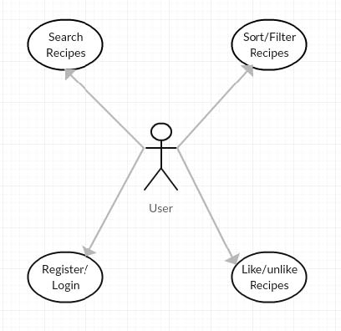

**Figure 4.1 Use case diagram**

The different actions that actor i.e. user can perform with application are register with application, login to application, search for recipes, sort the results, create and manage favorite collection, logout of application.

**4.2 Class Diagram**

In UML, class diagram is a static structure diagram which describes the structure of a system by showing the classes, attributes and their relationships. It is the main building block in object oriented modeling. The classes represent the structure or framework for the main objects and interactions in the application. The class diagram consists of classes represented in boxes which contain three parts. The name of the class is contained in the upper part, with the attributes of classes in the middle part and the bottom part contains the methods or operations that the classes undertake. The following figure shows the class diagram of the application

**4.2 Work Flow of Project**

* First I developed a website prototype using HTML, CSS, and ASP.Net server controls.
* Then converted the prototype to the more dynamic website using AJAX and Executed Development Yummly.Com.API
* Developed and test the Web applications
* Used Yummly API and search filters functionality to search recipes likes appetizers, main course, drinks and desserts
* The application Communicate with yummly API to consume data from it

**Chapter 5 – Screenshot of Application:**

1. **Screenshot of Application:**

This is the screen shot **of home page of website.**

This is logo of website, It also works as **navigation to come back to home page** of the website

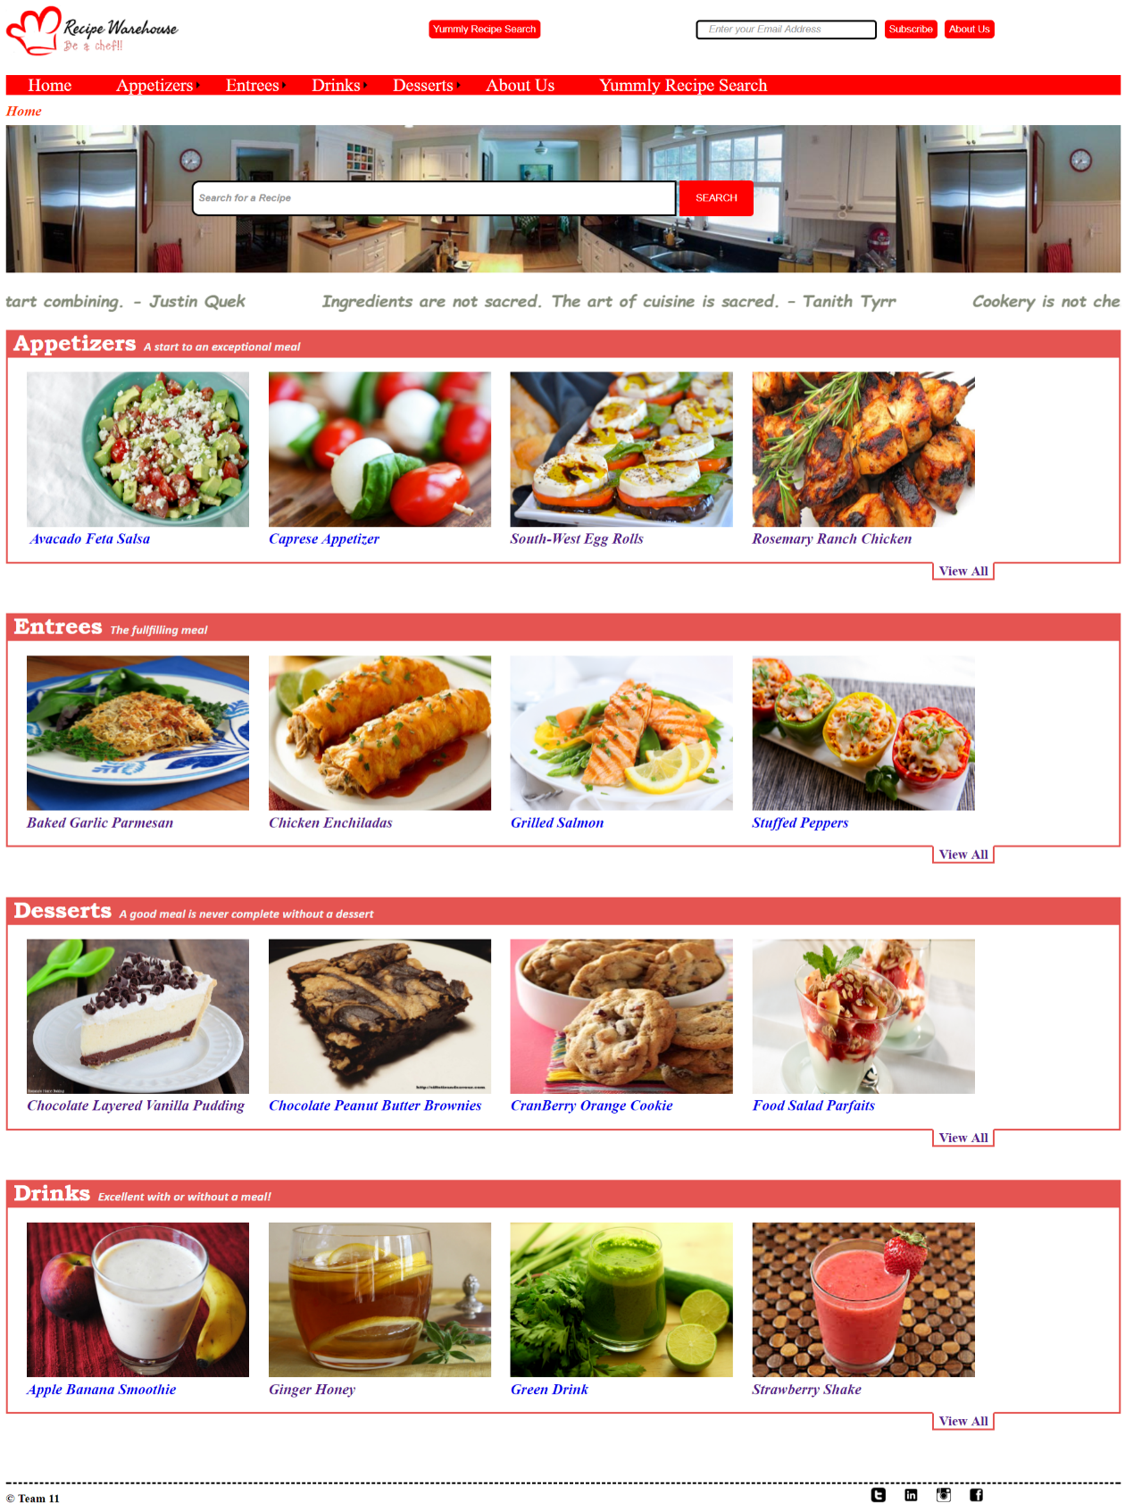  
**2. Screenshot:**

This is the screen shot of the **appetizer web page.**

It lists all the recent appetizers, plus in the search bar user could **search the appetizer** he/she looking for.

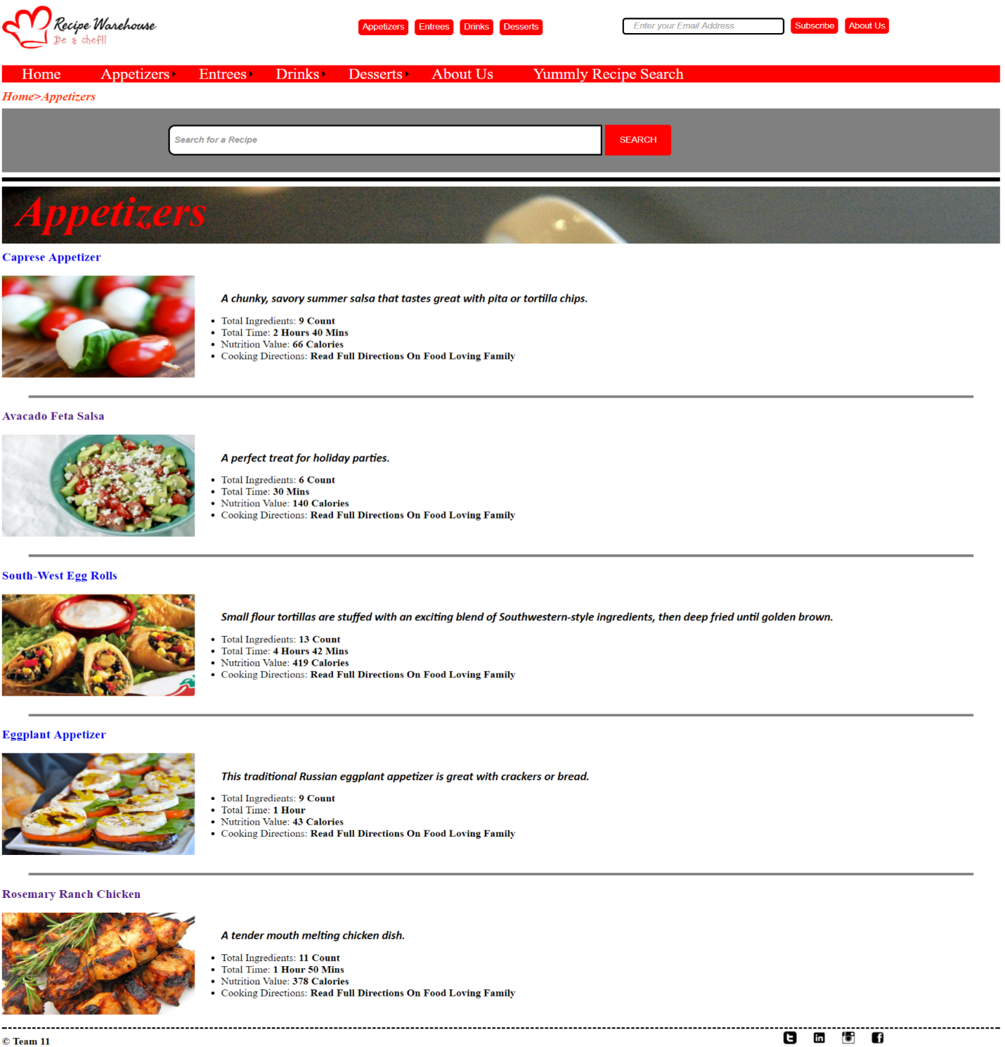

**3. Screenshot:**

I develop a search engine where user **could search the recipe using any keyword.**

It displays all the recipes with that **search keyword.**

The information includes **Ingredients, Ratings, Course, Cuisine, Holiday, Total Time, Full Recipe Information Link.**

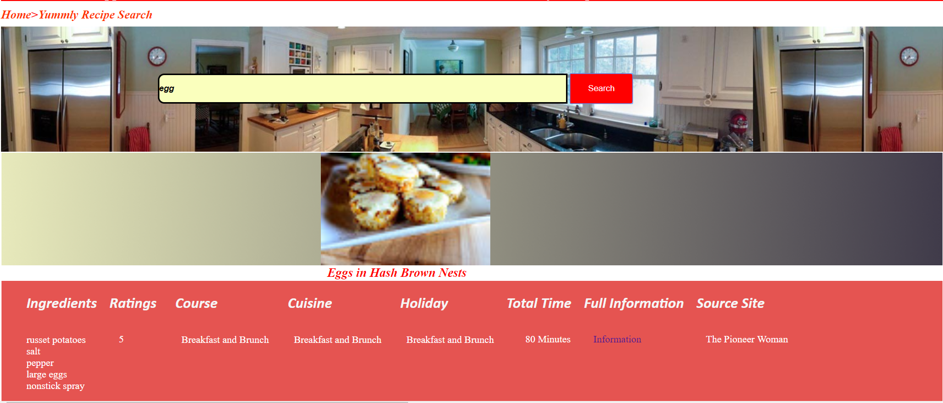

**4. Screenshot:**

This is display the details of the recipes with **photos, calorie count, time to cook, difficulty level, ingredients, and direction to cook.**

**Recipe photo**

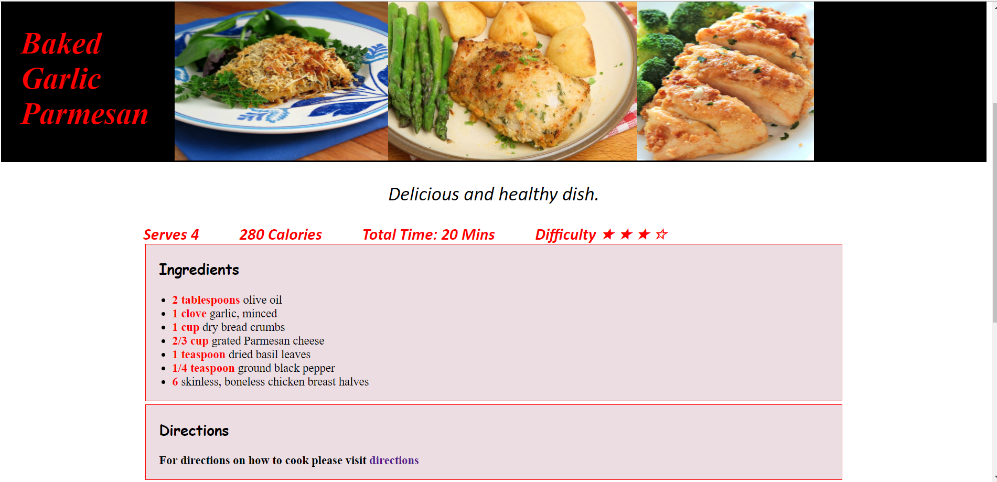

**Ingredients**

**Detailed information of recipe of dish (Serves Count, Calorie Count, Total time to cook, Difficulty level)**

**Direction to cook the dish**

**5.2 Web services**

Web services [5] are client and server applications that communicate over the World Wide Web’s (WWW) HyperText Transfer Protocol (HTTP). As described by the World Wide Web Consortium (W3C), web services provide a standard means of interoperating between software applications running on a variety of platforms and frameworks.

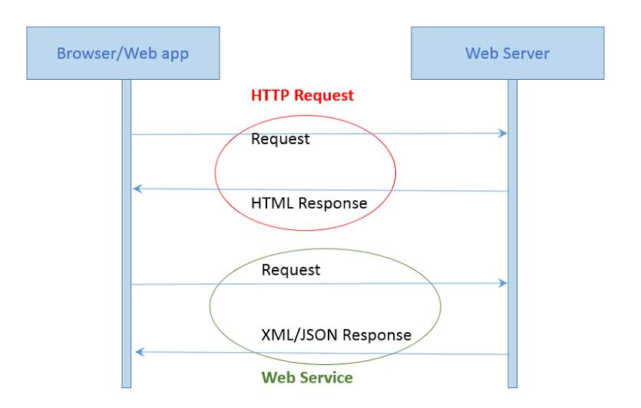

**4. Conclusion**

This Recipe Search Engine web application is developed to work as a central information hub for the kitchen—connecting consumers with recipe ideas, ingredient lists, and cooking instructions.

ASP.NET is used to design web pages and implement MVC architecture. Bootstrap, jQuery are used for creating interactive user interface. RESTful web services is used to communicate with the Yummly web API and pull data from it.

It was great experience to work on back end as well as front end technology.

During this project I learned all important web technologies and implementation of web services.

**To review my project code it is available on GitHub:** [**https://github.com/komalrahane/RecipeMaster**](https://github.com/komalrahane/RecipeMaster)